Name:__________________________________________ Date:____________________ Per:_________

Chapter 17B Review
- Describe the structure and function of transfer RNA.

- Why are aminoacyl-tRNA synthetases important for successful translation and protein synthesis?

- BRIEFLY explain the “wobble” hypothesis

- Describe the structure and function of ribosomal RNA – use the diagram below.
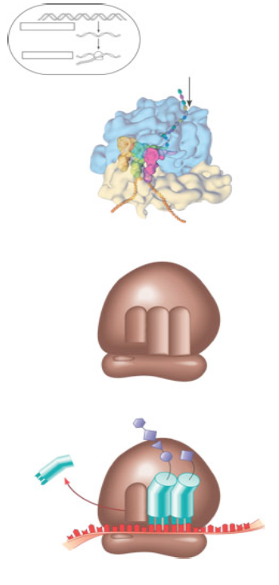
- Detail the process of initiation of translation.

- Use the diagram below to detail elongation cycle of translation. Explain each step.

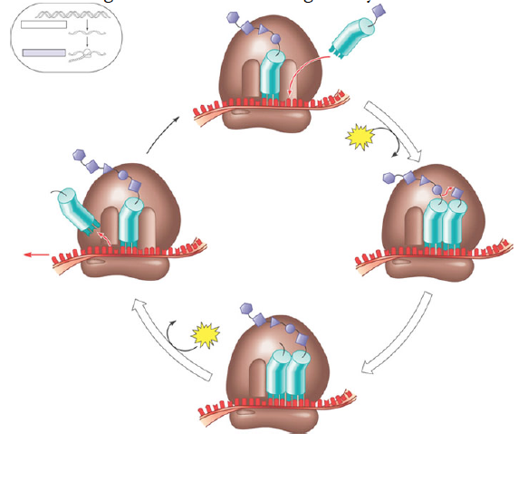

- Use the diagram below to detail the termination of translation. Explain each step.

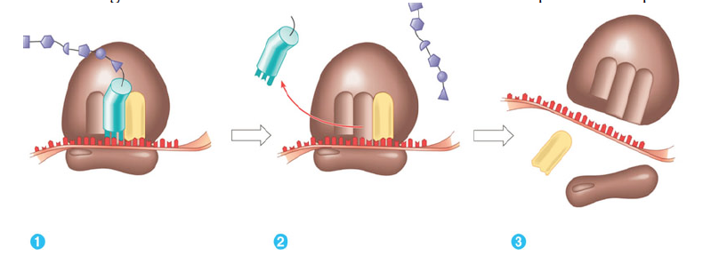
- What are polyribosomes?

- What is an example of a post translational modification of a protein?

- What is a signal peptide?

- What is the function of signal recognition particles?

- Use the diagram below to highlight the signal mechanism for targeting proteins to the ER.
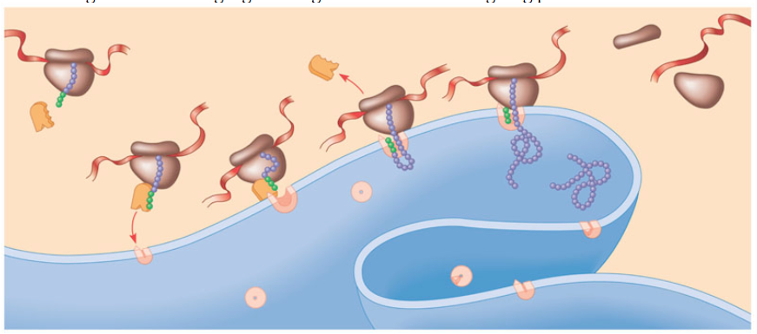
- Define the following terms:
a. Mutations

b. Point mutations

c. Base pair substitution

d. Missense

e. Nonsense

f. Insertions

g. Deletions

h. Frameshift mutation

i. Mutagen

- How has the historical concept of a gene been “redefined” during the last 100 years?

- Use the diagram below to help you explain the brief “whole” picture.
