Name:__________________________________________ Date:____________________ Per:_________

Chapter 17 Review

- Explain the flow of genetic information in living things. What are the processes called that allow our genetic material to be turned into proteins that control our phenotypes?

- What did Garrod mean by “inborn errors of metabolism?”

- Remembering from our DNA timeline activity and using Figure 17.2 walk through Beadle and Tatum’s Neurospora experiments explaining both the wild types and mutants and the conclusions they came to. Use to figure below to help you.
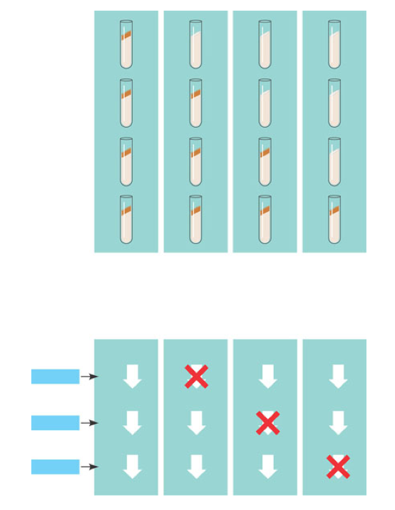
- Why does the genetic code occur in triplets and not singles or doubles?

- Compare and contrast the codon and anticodon. What are they and where are they found?

- How did Nirenberg figure out which amino acids went with which codes?

- Explain the concept of a “reading frame.”

- What conclusions can be drawn from the similarities of the genetic code among living organisms?

- Use the diagram below to understand transcription. Define all terms.
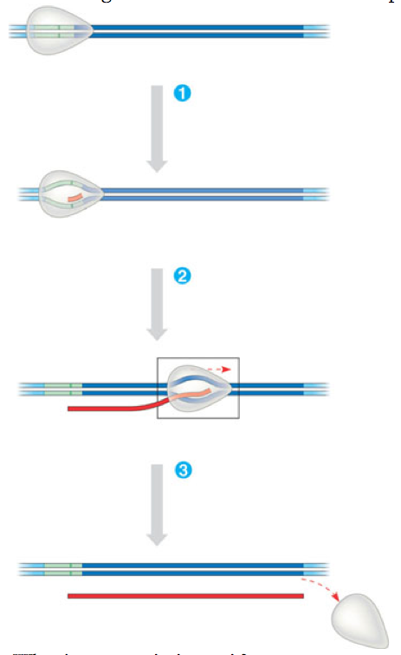
- What is a transcription unit?

- Describe the structure and function of the prokaryotic promoter and terminator.

- Use the diagram below to demonstrate initiation of transcription at a eukaryotic promoter. Define all terms.

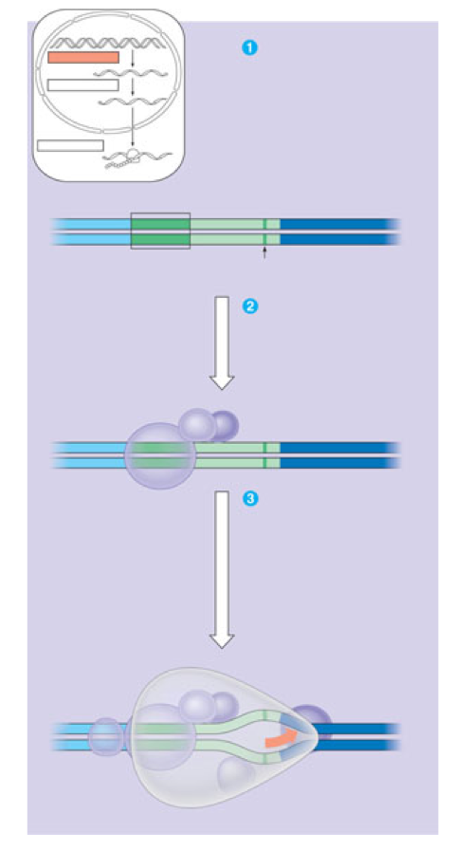

- Contrast termination of transcription in prokaryote and eukaryote organisms.

- Why is it important that the promoter be upstream of the transcription unit?

- Why is RNA processing necessary in eukaryote genomes?

- What does adding a 5’ cap and poly A tail do to the transcript and why is it important for successful protein synthesis?

- Define the following terms:

- RNA splicing

- Introns

- Exons

- Spliceosome

- snRNP’s

- ribozymes

- UTR

- Alternative

- RNA splicing

- domains

